Evaluating Disaster Risk Management Policy Frameworks: A Rapid Screening Tool
Methodological Note
Link: https://cat-ddo-drm-diagnostic-dashboard-129737065802.us-central1.run.app/
Introduction
Strengthening Disaster Risk Management (DRM) policy frameworks is an essential condition for economic stability and job protection. However, there is no widely agreed set of criteria defining what constitutes an effective and mature DRM system, making objective assessment challenging. In the absence of clear standards, it becomes difficult to evaluate the policy and institutional setting for DRM and rigorously measure progress. This lack of clarity ultimately hampers the identification of gaps and priority reforms, stalling the transition from reactive disaster response toward a proactive, strategic approach to managing disaster and climate-related risks.
To address this gap, this tool provides a high-level, rapid assessment of a country’s DRM policy framework. It evaluates national DRM policy frameworks against a standard global benchmark that reflects lessons learned and established good practices underpinning effective DRM systems. To ensure an objective evaluation, the tool utilizes a series of yes/no questions structured across the DRM thematic areas of this global benchmark (figure 1). Within each DRM thematic area, these binary questions review whether the fundamental dimensions of an enabling policy environment are present. Consequently, the evaluation is not based solely on the existence of formal laws or regulations. It also accounts for the clarity and coherence of institutional mandates, the strength of coordination mechanisms, the enforceability of rules, and the alignment of resources with strategic objectives.
This tool supports in-country DRM policy dialogue, operational engagements, and technical assistance design. Based on task team inputs, it automatically computes maturity levels across each DRM thematic area and generates a quantified snapshot of a country’s DRM policy framework. Delivered through a web-based platform, the tool facilitates the identification of relative strengths and weaknesses within the DRM policy framework and supports the prioritization of reforms that may be considered for support under DPF operations (including but not limited to DPF Cat DDOs).
The diagnostic should be understood as an entry point for structured policy dialogue rather than a definitive or exhaustive assessment. It can be applied periodically to monitor changes in policy maturity and track reform progress over time. Importantly, while the diagnostic highlights the distance between the current policy setting and a standard benchmark framework, it does not provide prescriptive guidance on the future development of the DRM system. It should be complemented with more in-depth analysis and qualitative insights to further advance the understanding of existing DRM practices and provide relevant policy advice.
Defining maturity levels for the different DRM pillars and thematic areas
Developing a sound DRM policy assessment requires a system-wide perspective. DRM cuts across infrastructure sectors, such as energy, water, transport, urban development, as well as socioenvironmental sectors, such as education, health, social protection, and environmental management. Disaster risk also affects economic growth and fiscal stability. In short, disaster risk is a development challenge arising from the interaction of hazard, exposure, and vulnerability conditions. While having a sound regulatory framework in place to manage the immediate impacts of disasters is vital, building resilience therefore requires a more comprehensive, multisectoral policy approach.
Recognizing this, the tool draws upon the World Bank DRM framework to provide a structured approach to evaluate a country's policy and institutional setup for DRM. This framework is organized around six essential DRM policy dimensions that help shape the DRM policy dialogue at the country level and identify key institutional counterparts for engagement.
Figure 1. The DRM policy framework: pillars and thematic areas
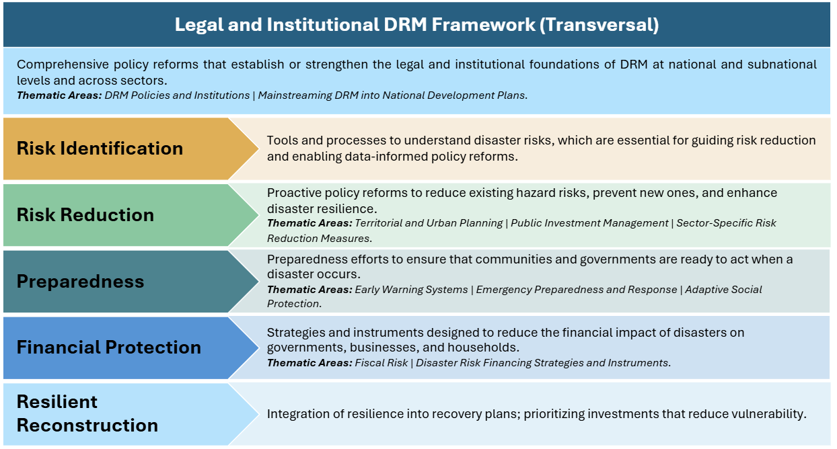
The tool enables the assessment of national DRM policy frameworks through a structured review of key dimensions under each pillar and thematic area. In practice, for each thematic area, maturity levels are determined through questions designed to reflect the logic of the results chain applied in DPF operations, progressing from policy and institutional inputs, through the implementation of reforms, to outputs and outcomes that contribute to strengthening disaster resilience. This structured approach is also informed by established practices in rigorous policy evaluation. Each question thus captures a core attribute used to compute the maturity score of a given thematic area. These attributes broadly relate to three major dimensions:
- Legal and regulatory framework: Strong and adequate normative frameworks are required to mandate risk reduction measures, retrofit infrastructure, establish risk-informed urban planning processes, enforce risk-informed standards, establish emergency powers, and set up disaster risk governance mechanisms, among other actions. For each thematic area, the initial questions therefore review whether the national legal and regulatory framework establishes binding norms for DRM priority actions (e.g., risk-informed zoning, disaster-resilient building and/or infrastructure standards, emergency preparedness planning, risk-financing mechanisms).
- Institutional architecture: Fragmented mandates or weak coordination can significantly undermine risk reduction efforts and disaster response. For each DRM thematic area, targeted questions examine the clarity of mandates, allocation of responsibilities, and coordination mechanisms across institutions responsible for disaster risk reduction and emergency preparedness and response. When relevant, this also includes specific questions assessing vertical integration across national and subnational levels.
- Implementation capacity and outputs delivered: The effectiveness of DRM policy interventions depends on the alignment of capacities, incentives, and resources across actors. To capture this critical dimension, the tool includes questions related to budget allocations, the existence of operational guidelines, and enforcement practices that shed light on whether institutional mandates and legal provisions are matched by adequate financial and technical resources. In addition, selected questions assess whether standard outputs expected within a specific DRM thematic area are being delivered, signaling a higher level of institutional maturity over time.
Guidelines for using the tool
This is a high-level assessment designed to be objective and quick. The tool assesses each thematic area using a set of closed Yes/No questions presented in an offline questionnaire (included in annex 1). Users should review official documentation (legal, regulatory, institutional, and budgetary) and consult with colleagues and national authorities to provide an informed answer. This is particularly relevant for cross-cutting questions, where inputs from colleagues from sectors such as Water, Transport, Health, and Agriculture may help in gathering information. In practice, when no evidence is available to support either a positive or negative response, it most often indicates that the conditions required for policy implementation have not been fulfilled. Once questions are completed, the web tool aggregates answers at the thematic area and pillar levels, computes scores, and generates visual outputs.
The maturity of each thematic area and pillar is defined as the distance to the DRM policy frontier. Responses are aggregated to produce a score, which is then compared to the maximum possible score under each thematic area or pillar to capture the gap between the country’s current DRM policy setting and the idealized benchmark. Under each thematic area, individual questions are equally weighted to avoid bias towards a specific policy dimension. Based on the share of points achieved, thematic areas and pillars are classified into four maturity levels—Nascent, Emerging, Established, and Mature (figure 2).
Figure 2. The maturity levels associated with different share of positive responses
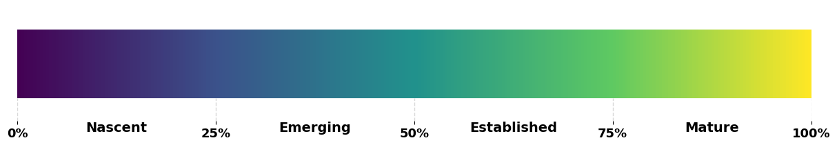
Interpretation of assessment results
Results are presented at the pillar and the thematic area levels to reflect the system-wide perspective required to evaluate the DRM system. The petal diagram generated by the tool encapsulates this systemic vision (figure 3). This diagram can be leveraged to effectively communicate the results of the assessment with CMU or counterparts. Petal length represents the maturity level achieved under each thematic area: the longer the petal, the more advanced the country is in this dimension. Conversely, shorter petals indicate areas where the policy and institutional set up is weak, not enforced, and/or not producing the expected outcomes. On the other hand, progress across different petals reflects the extent of DRM mainstreaming across key sectors.
Figure 3. DRM policy framework maturity: Illustrative results by thematic area
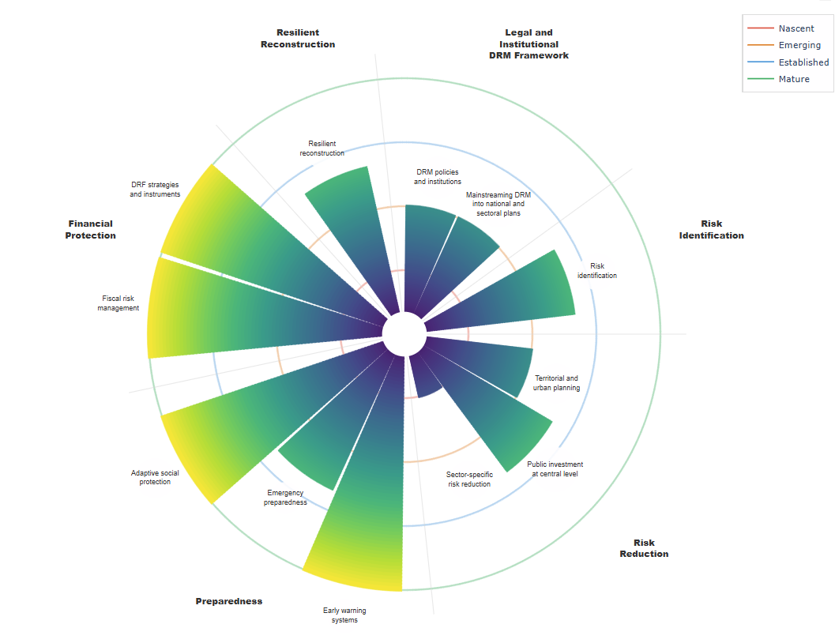
Together, these dimensions provide key insights into the overall maturity of the national DRM system. Countries with mature DRM systems typically have most petals exceeding the nascent level, with some approaching the frontier (i.e., exhibiting a level of advances close to the global benchmark frontier). Results are also aggregated by DRM pillar to highlight key strengths and gaps in a more succinct way. Finally, a text generated through a Large Language Model summarizes the results.
Figure 4. Illustrative example of results by DRM Pillar
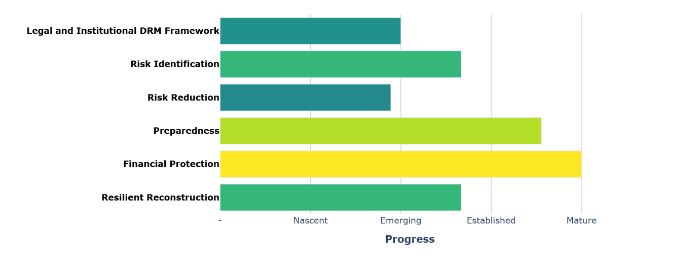
To conclude, it is important to note that countries differ widely in governance structures, socio-economic conditions, and institutional capacity. Progress across DRM thematic areas and policy dimensions is therefore not linear. Countries face diverse risk profiles and operate within distinct legislative and institutional environments in which their DRM systems must evolve. In lower-capacity settings, specific thematic areas may fall into the nascent category not because reforms are weak or insignificant, but because DRM systems remain at an early stage of development and are not yet producing the outputs captured by the binary questions. Conversely, countries with long-standing DRM systems may be delivering some of the targeted outputs even where the underlying legal and regulatory framework remains comparatively weak.

Annex: Questionnaire (Yes / No)
- Legal and Institutional DRM Framework
1.1. DRM policies and institutions
- Is there a legal framework (e.g., a DRM law or other legally-binding instruments) defining distinct responsibilities for disaster risk reduction and emergency management?
- Did the institution responsible for coordinating or leading DRM activities receive dedicated funding for these functions in the last fiscal year?
- Have DRM policy instruments (e.g., DRM strategies or policies) been officially approved since the adoption of the DRM legal framework?
- Have DRM-related regulations (e.g., rules on the structure or functions of the DRM agency) been officially approved since the adoption of the DRM legal framework?
1.2. Mainstreaming DRM into national and sectoral development plans
- Does the National Development Strategy (or equivalent national planning instrument) contain objectives, targets, or indicators related to DRM and/or Climate Change Adaptation?
- Have at least 50% of essential government entities included explicit DRM and/or Climate Change Adaptation targets and indicators in their most recent strategic planning documents?
- Risk Identification
- Do laws and regulations clearly define institutional responsibilities and mandates for producing, acquiring, and managing geospatial information, including risk information (e.g., hazard information, vulnerability assessments, risk profiles, historical disaster databases)?
- Is existing hazard and risk information available to all essential government entities (e.g., as evidenced through Memorandums of Understanding or formal exchange mechanisms)?
- Is existing hazard and risk information accessible to all citizens through open-data platforms?
- Do available national risk assessments or disaster risk profiles account for the potential impacts of climate change on hazard intensity and frequency?
- Risk Reduction
3.1. Territorial and urban planning
- Do laws and regulations mandate the use of risk information (e.g., hazard maps, risk assessments) to develop territorial, spatial, land use, or urban planning instruments?
- Do official methodologies to guide the development of risk-informed territorial, spatial, land use or urban planning instruments exist?
- Do guidelines or procedures for managing housing/settlements located in high-risk areas exist?
- Have at least 50% of the instruments (territorial, spatial, land use or urban planning) approved in the last four years used risk information (e.g., hazard maps, risk assessments)?
3.2. Public investment at the central level
- Do laws and regulations mandate disaster and climate risk screening as part of the appraisal of new public investment projects?
- Do official guidelines exist defining disaster and climate risk screening methodologies for new public investment projects?
- Are risk mitigation measures mandatory for new projects that have been appraised as high-risk (or equivalent) through the disaster and climate screening process?
3.3. Sector-specific risk reduction measures
- Are there legally binding standards or technical guidelines for the design and construction of disaster-resilient critical infrastructure in the following sectors: (1) transport (roads), (2) education (schools), (3) health (hospitals), and (4) energy infrastructure?
- Is there at least one legally binding building code or standard that requires earthquake-resistant or other hazard-resistant (e.g., wind, flood) design for buildings?
- Has any public project or program in the past four years been allocated funding for retrofitting activities that follow vulnerability assessments and resilient design standards?
- Are there legal and institutional arrangements for water supply and sanitation in urban areas that take flood risk into account?
- Are there legal and institutional arrangements for integrated water resources management that explicitly incorporate flood and drought risk considerations?
- Have any watershed basins undergone improvements in water management in the last four years?
- Has the percentage of urban residents with access to sewage services been maintained or increased in the last four years?
- Preparedness
4.1. Early Warning Systems (EWS)
- Do institutions involved in EWS—data producers, decision-makers, and implementers of preparedness and response—operate under an established, functional coordination mechanism, evidenced by formal arrangements such as Memorandums of Understanding or regular coordination platform meetings?
- Over the most recent major disaster, was the population promptly alerted (e.g., via SMS or other tailored communication channels)?
- Over the past four years, has there been at least one budget allocation for the expansion, maintenance, or operation of the hydrometeorological network?
4.2. Emergency Preparedness and Response (EP&R)
- Is there a legal framework for EP&R clearly defining the roles and responsibilities of institutions involved in disaster management?
- Do at least 50% of essential government entities have an emergency response protocol or operational continuity plan?
- Do at least 50% of subnational EP&R entities (e.g., Local Emergency Management Committee) have an approved contingency plan or emergency response protocol?
- Do emergency preparedness plans incorporate gender-sensitive measures, such as gender-based violence prevention, safe shelters, and women's specific needs during evacuation and displacement?
4.3. Adaptive Social Protection (ASP)
- Is there a legal framework clearly defining the roles and responsibilities of institutions involved in ASP (e.g., social protection, finance, DRM)?
- Is there a unified social registry incorporating exposure and vulnerability data to facilitate the targeting of population potentially affected in case of disaster or climate-related shocks?
- During the most recent disaster or climate-related shock, was support promptly provided to the population through social‐protection programs? (e.g., cash transfers)?
- Financial Protection
5.1. Fiscal risk management
- Has the Ministry of Finance created or tasked an existing institutional structure (e.g., department, unit, committee) to manage contingent liabilities and/or fiscal risks, explicitly including those associated with disasters and/or climate-related shocks?
- Are contingent liabilities associated with disasters quantified through an established methodology for the major hazards?
- Do key fiscal policy documents (e.g., the medium-term fiscal framework or fiscal risk statements) include quantified assessments of disaster risks?
- Has the government conducted stress tests of public debt that include disaster or climate-related scenarios?
5.2. Disaster Risk Financing (DRF) strategies and instruments
- Are there sovereign risk financing instruments (e.g., disaster or emergency funds, contingent loans, insurance, cat bonds) in place to manage the financial impact of disasters and climate-related shocks?
- Are there regulations that define standards for catastrophe insurance coverage of public or private assets?
- Over the past four years, has the $ amount of financing that can be mobilized through sovereign risk financing instruments increased?
- Resilient Reconstruction
- Are there laws or regulations that establish the institutions responsible for coordinating post-disaster recovery and reconstruction?
- After the most recent major disaster, have the zoning, land use or territorial planning instruments in the affected areas been reviewed to build back better?
- Have guidelines or regulations to conduct post-disaster damage and needs assessments been developed and approved?

The design of this idealized framework has been informed by a comprehensive review of DRM policy programs supported through Development Policy Financing (DPF) with Catastrophe Deferred Drawdown Options (Cat DDOs). It is aligned with established DRM frameworks, including the IDB’s IGOPP and the Sendai Framework. The design of this benchmark also draws on core concepts from the public administration and governance literature to determine whether policy commitments are coherently designed, operationally resourced, and systematically enforced and refined over time (see Peters, B. G. (2010). The Politics of Bureaucracy. Routledge).
Drawing on country experiences and global good practices, this framework was first proposed in The Sendai Report (Ghesquiere et al. 2012) and is aligned with the Sendai Framework for Disaster Risk Reduction. It is also used in the Driving Policy Reform for Disaster Resilience report (World Bank 2025).
Responses are scored in a binary manner: affirmative responses receive one point, and negative responses do not receive points. An “Unknown” option is also available and is treated as a negative response.
Disaster risk is highly context-specific, and the diagnostic provided by this tool is only an initial step toward developing an appropriate and effective DRM policy program. For more details, the reader is referred to the Driving Policy Reform for Disaster Resilience report for further guidance on how to structure a context-relevant DRM policy program.
Essential government entities refer to the main ministry or agency in charge of the followings eight sectors: Agriculture, Education, Housing, Health, Energy, Tourism, Transport, Water and Sanitation.

